**Linux Administration**

**Assignment-1**

Question-1: Create a blank file named "myfile"

Ans:-

Command:-**touch myfile**

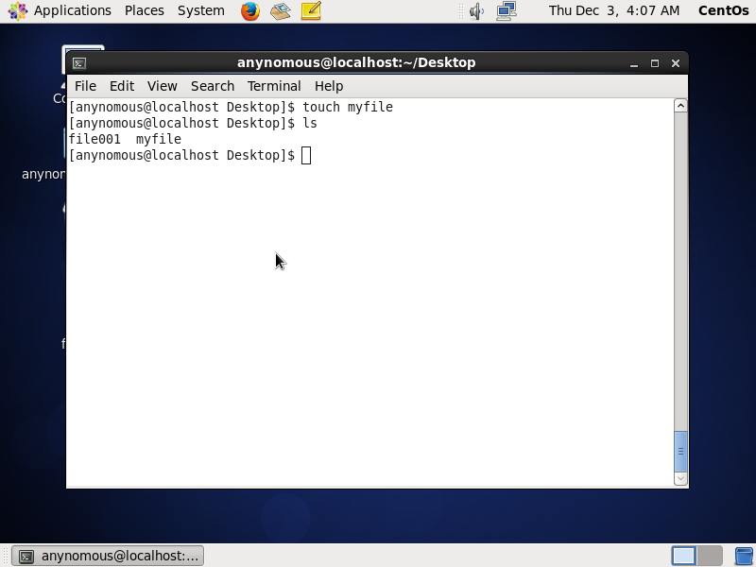

Question-2: Open "myfile" in vi editor

Ans:

Command:- **vi myfile**

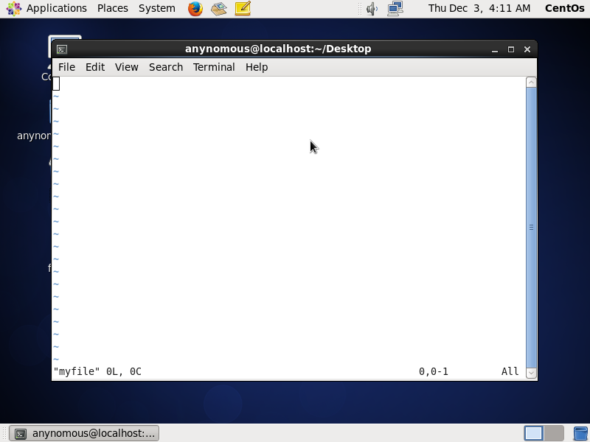

Question-3: Write your name, address, email id, phone number and blood group in 5 different lines

Ans:-

Commands:- **i 🡪** to insert

**Esc🡪**to exit from insert mode

**:wq🡪** to write and quit

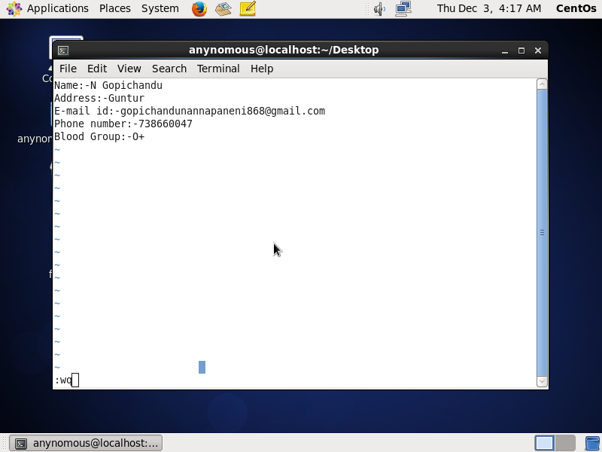

Question-4: Build one single expression to see the line with your name and blood group in myfile

Ans:-

Command:-**cat myfile | grep -e ‘Name’ -e ‘Blood Group’**

